# Lab Three Project Plan:

You need to develop a project plan that your two teams can use as a way to coordinate your activities. Be sure to post this to MyCourses after you have developed it.

## Deliverables:

Project plans turned in should meet or touch on the following requirements

* Preliminary report of functionality what is the goal of this lab? What services do you plan to deploy and what architecture do you plan to use to do it?
* Expected deliverables of the project
* Links to relevant research if necessary. Reading a few stackoverflow or RFCs before beginning something goes a long way.
* Expected issues or pit falls
* Time line of the steps in the project with people and completion dates assigned to the steps.

These should be helpful to outsiders or other teams. Keep that in mind while writing.

# Project Plan:

|  |  |
| --- | --- |
| Group Number: | 4 |
| Group Members: | Nate Bachelder (Formerly Williams), Steffen Barr, Eli Hopkins, Xavier Rivera |
|  |  |
|  |  |
| Version/Lab Number: | Lab 3 |
| Date: | 10/15/21 |

NSSA 320 Project plan to be completed by each group to help the group develop a plan to complete a lab. Fill in the table below with a short description that answers the question.

## Project Description:

|  |  |
| --- | --- |
| What are your project goals | Our project goals are to scale out the Explore California website to be hosted on 3 web servers behind a load balancer. |
| What do you aim to accomplish? | We aim to accomplish the project goals while allowing for an expected load of 300 users. |
| What additional resources are required? | Nginx is required to host the load balancer. |
| Success/Definition of successful completion | The project is successful if the sites are functional and behind a loadbalancer. The architecture should support well over 300 concurrent users. |

Below is an example timeline that can serve as the basis of your group Gantt chart for completion of the lab. Be sure to assign people to the individual steps.

## Project Timeline and Order with Milestones

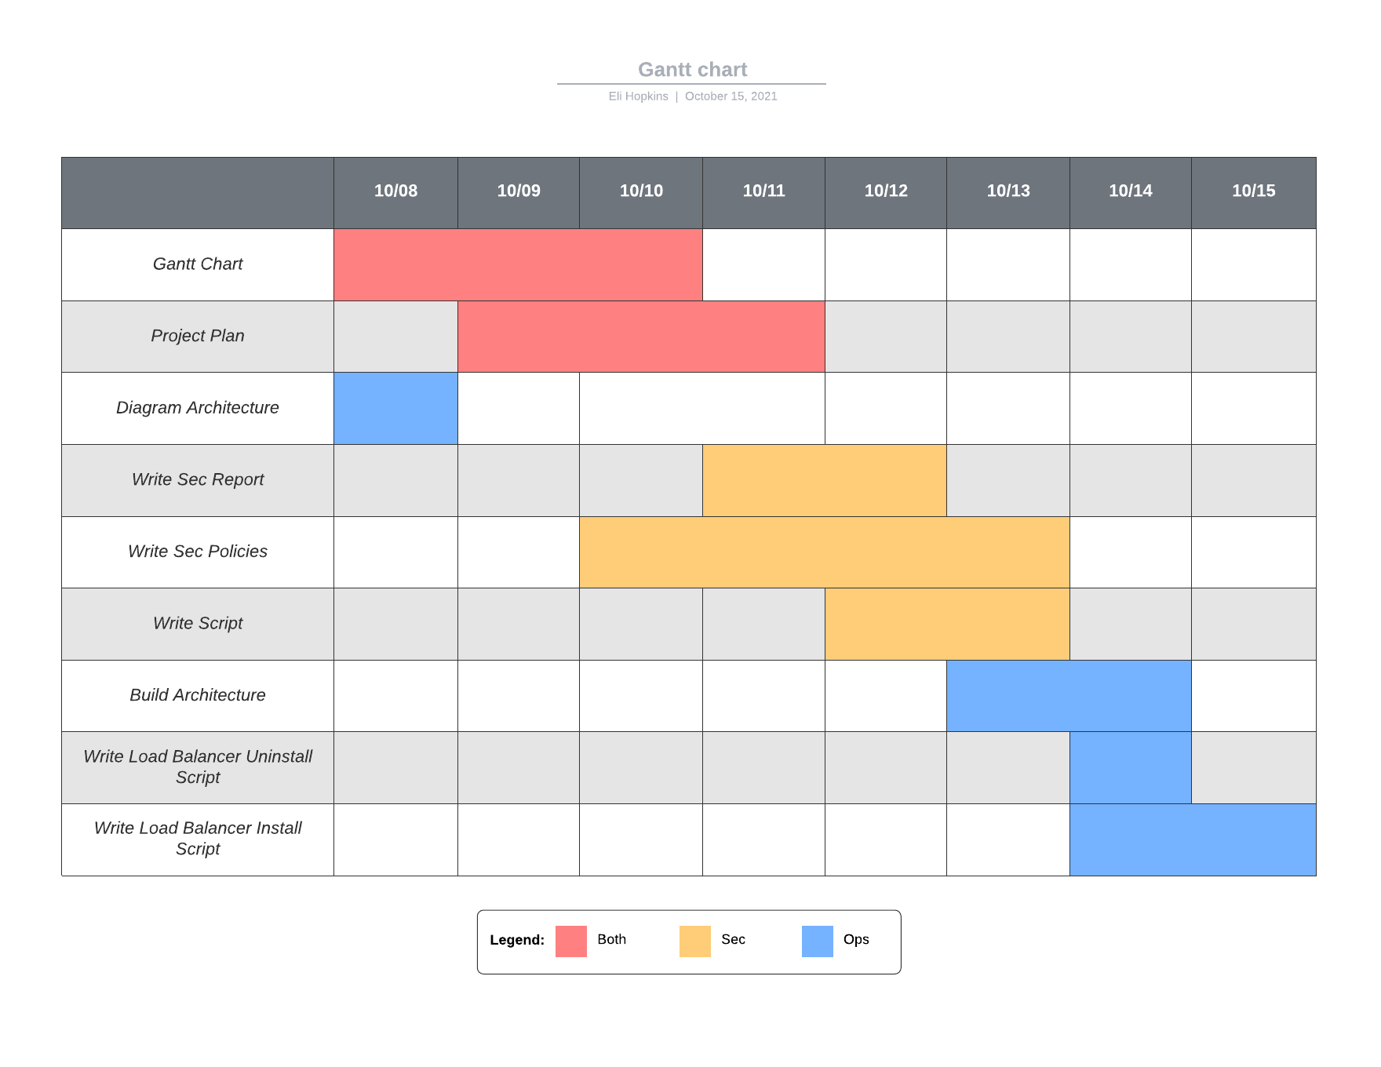

## Visio Diagram of your completed deployment architecture:

